SESSION 1—HANDOUT 3

THE EIGHTH WONDER OF THE WORLD: COMPOUNDING—A MIXED BLESSING

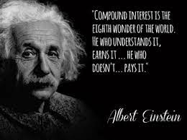

COMPOUNDING IS A BEAUTIFUL THING
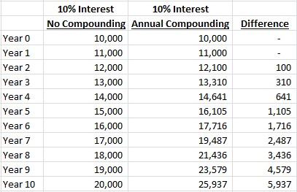
Not very dramatic…
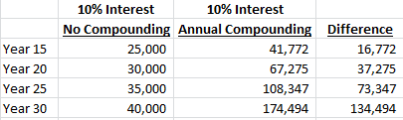
Dramatic!

COMPOUNDING IS A DANGEROUS THING
Scenario 1:
Refrigerator Purchase on credit: $550.00
Interest 18.9%
Minimum payment (4%): $22 per month
Pay for 4 years 11 months $768.97
Interest $ 218.97

3 months later--Car Transmission Purchase on credit: $1900.00
Credit card balance now $2384.00
Interest 18.9%
Minimum payment (4%): $95.36 per month
Pay for 8 years 10 months $3794.00

Total purchases ($550 +$1900) =$2450
Paid out ($66 + 3794) =$3860
Interest is $1410.00.

What Is the Minimum Payment on a Credit Card? The minimum payment on a credit card is the lowest amount of money the cardholder can pay each billing cycle to keep the account's status “current” rather than “late.” (Late fees are enormous.) A credit card minimum payment is often $20 to $35 or 1% to 3% of the card balance, whichever is greater.

Scenario 2: You struggle with the payments--$95.36

Refrigerator Purchase: $550.00
Interest 18.9%
Minimum payment (4%): $22 per month
Pay for 4 years 11 months $768.97
Interest $ 218.97

3 months later--Car Transmission Purchase: $1900.00
Credit card balance now $2384.00
Interest 18.9%
Minimum payment (2%): $47.69 per month
Pay for 30+ years $9,166.87

Total purchases ($550 +$1900) =$2450
Paid out ($66 + 9166.87) =$9232.87
Interest is $9232.87-2450=$6782.87.
You are still paying for your refrigerator and transmission 30+ years after you bought them. Does the refrigerator still run? Do you still have that car? No, but you are still making payments.

Scenario 3: You save $50.00 per month for 1 year--$600

Refrigerator Purchase: Pay $350, finance $200 $200.00
Interest 18.9%
Minimum payment (4%): $15 per month
Pay for 15 months $225.00
Interest $ 25.00

3 months later— Savings =$400
Car Transmission Purchase Pay $250, finance $1650.00 $1650.00
Credit card balance now $1805.00
Interest 18.9%
Minimum payment (3%): $55.50 per month
Pay for 11 years 6 months $3556.66

Total purchases ($550 +$1900) =$2450
Paid out ($66 + 3556.66) =$3622.66
Interest is $3522.66-2450=$1172.66.

BUT THIS IS INTEREST FREE FOR 12 MONTHS!
Miss a payment? Interest free is gone and you may owe accumulated interest.
How can they loan you money for free?

NO PAYMENTS FOR A YEAR!
So how will you pay for it in a year? Save up the money? Make payments to yourself.

CAN’T PAY CREDIT CARD DEBT? https://www.incharge.org/debt-relief/credit-counseling/new-york/

